Current Footprint Analysis

Unregulated Operators

In 2022, the province of Ontario legalized the private sector's online gambling licensing, reshaping the landscape of online gambling in Canada. This new development triggered an advertising surge for the Ontario-licensed platforms that are yet to be regulated in other provinces, making it hard to distinguish such platforms from the provincially regulated gambling platforms that generate revenue and employment. Most customers are thus oblivious to the information that only one gambling website, PlayNow.com, is legal in B.C., thus making it hard for the platform to maintain its market leadership.

Problem Gambling Severity Index (PGSI)

The Problem Gambling Severity Index (PGSI) is an internationally recognized self-reported at-risk gambling behavior measure. It was devised by research into typical signs and implications of problem gambling and is used as an industry-wide standardised measure. There was consistent growth last year in the PGSI scores for PlayNow.com to the present level of 10%. This growth can be explained by increased engagement by core customers in two of the highest PGSI-risking activities—sports betting and online Keno. Of note, sports betting also demonstrated a notable growth in the average spend per visit during the 2022/23 fiscal year.

Website Traffic/User Engagement (www.playnow.com)
Total Visits (Feb 2025) : 2.802 M
Unique Visitors : 511.9K
Global Rank : #13,499
Country Rank : #267
Industry Rank : #44
Device Distribution : Desktop – 30.74%
Mobile Web – 69.26%
Geo – Canada Share : 96.3%
Average Visit Duration : 09:50
Pages/Visit : 10.58
Bounce Rate : 25.15%

Historical Data
Date | Aug 2024 | Sep 2024 | Oct 2024 | Nov 2024 | Dec 2024 | Jan  2025
Direct | 1.9M | 2M | 2.1M | 1M | 1.3M | 1.5M
Referral | 145K | 81K | 80.3K | 121K | 93.7K | 111K
Organic Search | 138K | 145K | 259K | 315K | 207K | 199K
Organic Social | 5.3K | 4.4K | 2.8K | 1.1K | 5.9K | 18.3K
Paid Social | 0 | 12 | 0 | 706 | 84 | 0
Paid Search | 25.9K | 13.4K | 18.7K | 22.4K | 13.4K | 24.8K
Display Ads | 1.3K | 621 | 615 | 919 | 2.2K | 713
Email | 45.3K | 25.8K | 22.9K | 46.1K | 33.3K | 316K
Description
Large number of total visits (2.802 M) with 18.2% of visits having a unique footprint. The bounce rate is 25% and on average visitors spend time browsing through 10 pages in 10 minutes. 2/3rds of the users of the website uses mobile. There was a 135% increase in growth seen in 2020/2021. PlayNow.com is the only online gambling provider within BC where profits flow back to the Government of B.C. It is both secure and regulated online with a portfolio of sports betting, lottery games, table games, slots, table games and bingo. In March 31, 2021, there were approximately 715,000 users registered on PlayNow.com. Users of the website also skew towards the younger male demographic (with slightly riskier gambling profile). The website also allows players to earn points with Encore loyalty system. Revenues in 2020/21 is over $420 million, a 74% increase in revenue from 2019/20. They also made it such that the users could have access to their Game Sense Advisor from 8:00AM to midnight on all days of the week. Playnow is also available in 3 provinces British Columbia, Manitoba and Saskatchewan. Major updates to their lineup include that ability for users to conduct single events betting

App downloads and reviews

PlayNow BC Sportsbook is ranked #137 in Sports.

Description:
This is the official PlayNow Sportsbook iPhone app for residents of British Columbia (Canada) only. With the PlayNow Sportsbook app you have instant access to B.C.’s only legal and regulated sportsbook. Download the app today for a user experience including:

LIVE In-Game Betting:
PlayNow.com allows users to place bets in real-time as the game unfolds on a wide range of leagues and markets across most sports.

Cash Out:
Cash Out & Partial Cash Out allows bettors to settle their bet early, before the event they bet on has concluded. This feature provides bettors with more control over their bets and the ability to secure a profit or reduce losses.

Same-Game Parlay:
Same-Game Parlay lets bettors choose multiple selections from within the same game into one single parlay. Same-Game Parlay bets are currently available for pre-game betting on NFL, NBA, NCAA Football, NCAA Basketball, Rugby, and Soccer.

Bet-Back-Bonus:
PlayNow.com’s “Bet-Back Bonus!” gives you a chance to win a matched Freebet up to $100 when your bet loses. Players can only qualify for one Freebet per promotion; applies to first qualifying bet placed.

Local Content
PlayNow Sports is the official sports betting partner of the Vancouver Canucks. PlayNow Sports offers B.C. Lions Odds Boosts prior to every Lions game during the CFL season. Making a wager on the game? Check out which bets have received an odds boost prior to kickoff in our Odds Boost Section!

Available Leagues
PlayNow.com offers betting on a wide range of leagues and sports from around the world. The exact number of leagues can vary depending on the season and availability, but generally PlayNow.com offers betting on all major professional leagues, such as the NBA, NHL, NFL, and MLB, as well as international leagues and tournaments for sports like soccer, tennis, golf, and rugby.

Betting Options
PlayNow.com offers a vast selection of bet types such as moneylines, spreads, totals, parlays, same game parlays, props, teasers, futures, and many others with competitive odds.

Account Security
BCLC understands how important information security and privacy are to you and we are committed to helping you keep your PlayNow.com experience secure and private. We use state-of-the-art technology and follow numerous security procedures to protect information contained in your PlayNow.com account. Users should always consider enabling security features such as anti-malware, anti-virus, and automatically enable system updates on there iOS devices and do not use any jailbroken devices for this app.

Safe & Secure Account Deposits and Withdrawals
We accept Visa, Mastercard, American Express, PayPal, Interac Online, Online Bill Payment & PlayNow Web Cash. For more information on the deposit options available on PlayNow.com.

Must be 19+ to play.

Version History (Raw Data for better decision making)

Version 2.3.0 – February 18, 2025
- Free bets can now be used on Same Game Parlays.
- Same Game Parlay Plus – Ability to parlay multiple SGPs and/or single bets.
- Mobile Quickslip – Instantly place single and straight-line combination bets.
- Multi-Rebet on Losing Leg – Easily place bets with the remaining legs of a losing parlay.
- Featured Same Game Parlays added.
- General enhancements and visual improvements to market layouts.

Version 2.0.5 – January 2, 2025
- Bug fixes and performance improvements.

Version 2.0.4 – January 3, 2024
- Updated location notification.

Version 2.0.3 – November 21, 2023
- Updated app branding.
- UI enhancements.

Version 2.0.2 – September 5, 2023
- Updated app store images.

Version 2.0.1 – August 24, 2023
- Updated screenshots.

Version 2.0 – June 13, 2023
- Sportsbook upgrades for an improved betting experience.
- New Features:
  - Parlay Boost on Soccer.
  - Quick Bets – Place single wagers directly without navigating to the betslip.
  - "Favourites" feature – Create custom coupons for easy navigation of preferred leagues.
- UX Enhancements – Improved app navigation.
- Bug fixes.

Version 1.0 – April 25, 2023
- Initial launch.

User Reviews
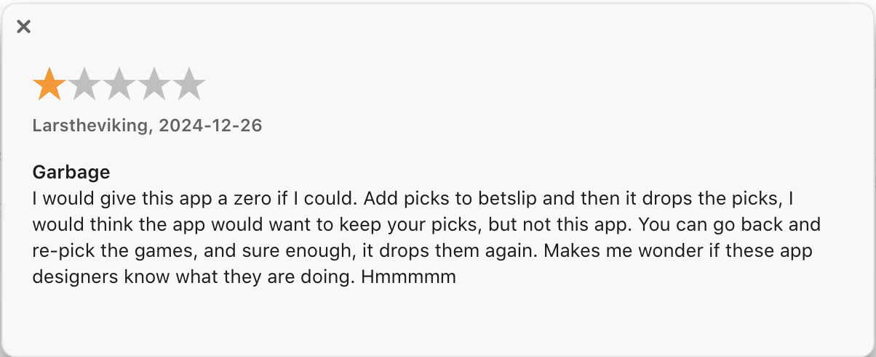

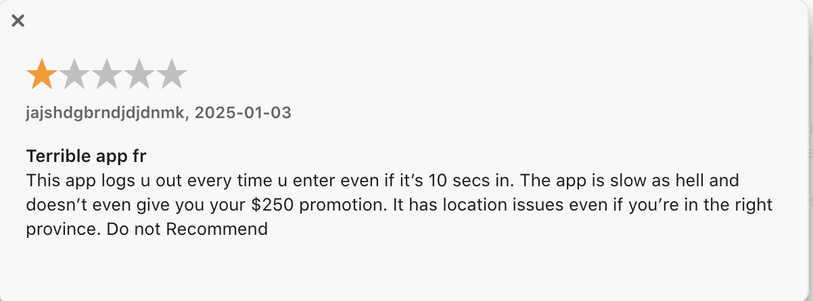

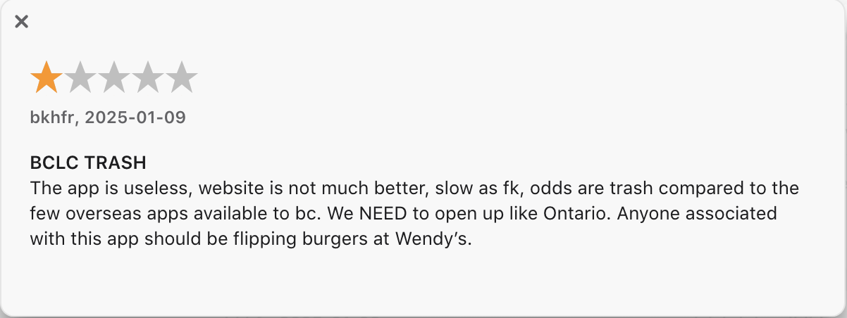

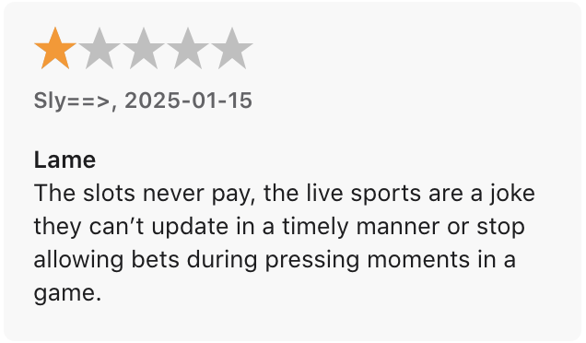

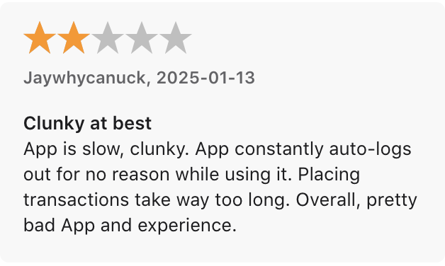

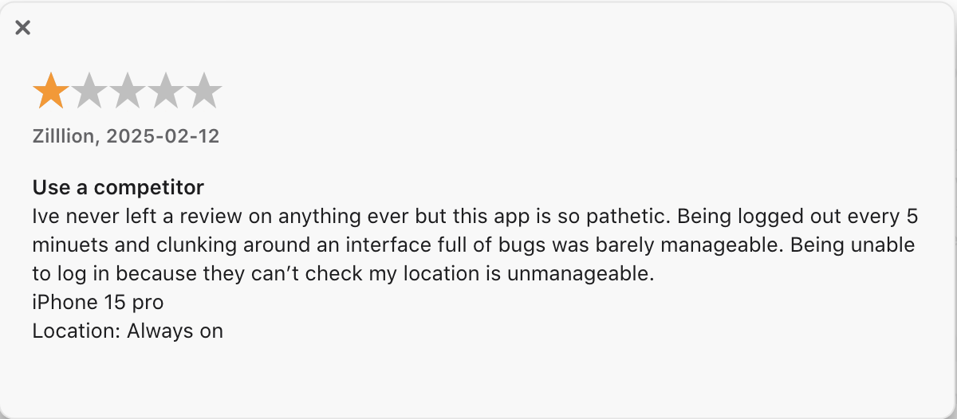

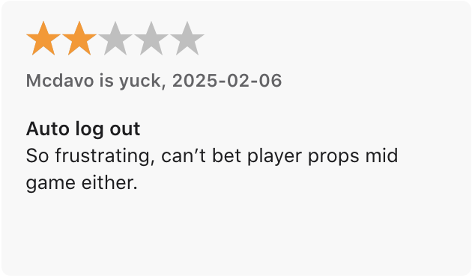

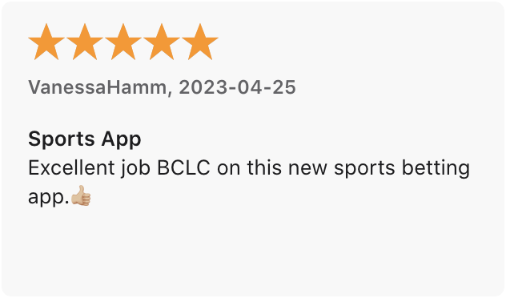

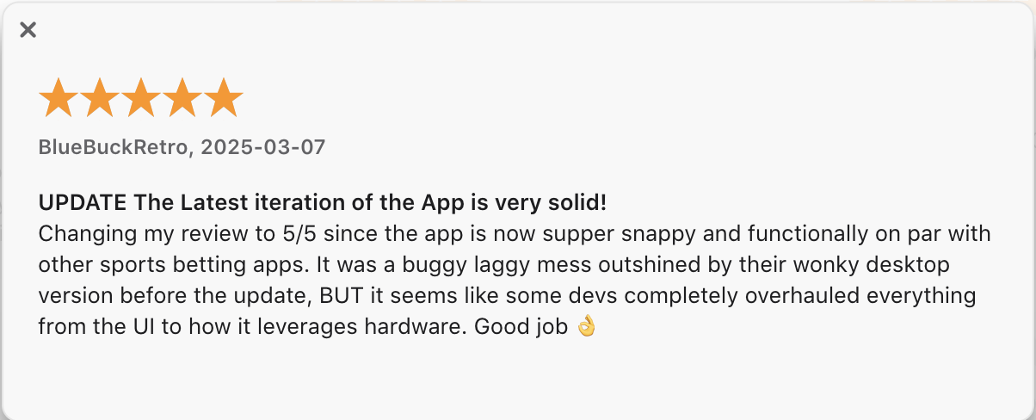

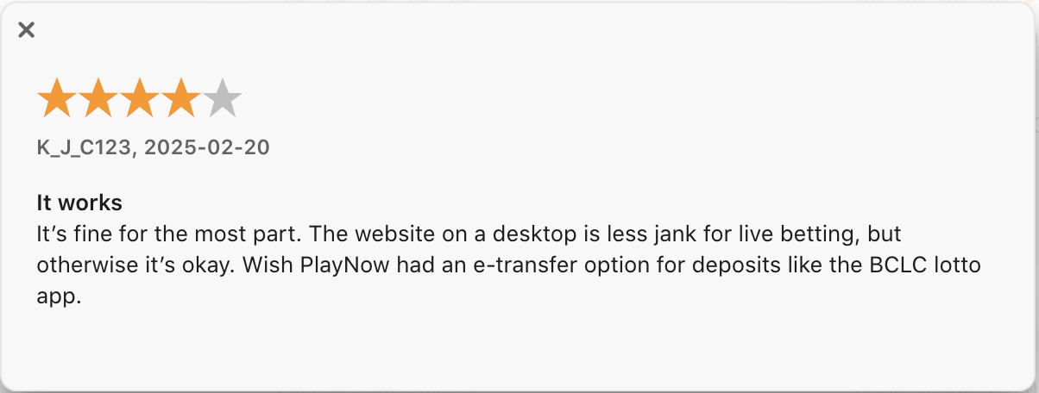



App Info
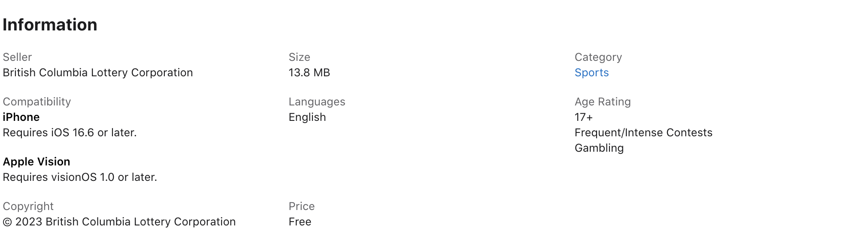

Player Demographics

Note this is for playnow, not for playnow/sports

Competitive Analysis

BCLC (PlayNow.com) vs. Bet365 and Betway in British Columbia

Comparison of Company Footprints:
The gambling industry in British Columbia (BC) is quite interesting because it has both a
government-regulated platform and international gambling operators competing for users. The British Columbia Lottery Corporation (BCLC), a Crown corporation established in 1985, is the only provincially authorized gambling provider, running PlayNow.com—BC’s official legal and government-regulated online gambling platform. Through this site, users can bet on sports, play casino games, poker, and lotteries, all within a secure and regulated environment. However, despite PlayNow.com’s exclusive legal status, Bet365 and Betway, two of the largest private online gambling companies worldwide, also attract BC residents. These international platforms operate in a legal gray area, meaning they aren't directly regulated by BC authorities, but since Canada’s federal laws do not explicitly ban foreign operators, people in BC can still access them freely. Although all three platforms provide similar services, their regulations, financial impact, betting options, and overall user experience are very different.

Since PlayNow.com is government-run, it operates under strict provincial laws and is overseen by the Gaming Policy and Enforcement Branch (GPEB). This means all profits from PlayNow.com go directly back into public services like healthcare, education, and community programs. In 2023 alone, BCLC generated over $1.3 billion in revenue, a good portion of which was reinvested into BC’s economy. Additionally, PlayNow.com follows strict responsible gambling policies, offering features like GameSense, self-exclusion options, and deposit limits to help users gamble responsibly. But while PlayNow.com has strong security and social responsibility measures, it’s often criticized for its limited betting options, fewer promotional offers, and an overall less competitive user experience compared to the big international platforms.

Meanwhile, Bet365 and Betway are privately owned gambling giants with millions of users worldwide. Bet365, founded in 2000 in the UK, has over 63 million registered users and is licensed by the UK Gambling Commission and the Malta Gaming Authority. Betway, which started in 2006 in Malta, holds similar licenses but has put a stronger focus on sports sponsorships and esports betting, making it especially popular among younger users. Unlike PlayNow.com, these companies do not contribute any revenue to BC’s economy, since they operate outside the province’s jurisdiction. However, their biggest advantage is their superior betting experience—offering better odds, more sports betting markets, and a more user-friendly platform.

One of the biggest reasons people prefer Bet365 and Betway over PlayNow.com is their more advanced betting features. Bet365 offers live streaming, in-play betting, and an extensive selection of international sports leagues, making it a favorite for serious bettors. On the other hand, Betway specializes in esports betting, offering a more modern and tech-friendly betting experience. Both platforms also provide generous promotions, cashback offers, and enhanced odds, which PlayNow.com cannot compete with due to its strict regulatory limitations on promotions.

That said, Bet365 and Betway come with their own risks. Since they are not officially regulated by BC authorities, users don’t get the same consumer protections that PlayNow.com offers. These platforms don’t have the same legal obligations for responsible gambling, and if any disputes arise, users might not have the same financial protections they would with a government-backed site like PlayNow.com. Additionally, while these companies follow international regulations, their profits go to private shareholders rather than back into BC’s public services. So while Bet365 and Betway offer a much better gambling experience in terms of features, they don’t provide the same security or economic benefits as PlayNow.com.

Overview: Website, Webpage, and Application Interface

After exploring the websites and mobile applications of PlayNow.com, Bet365, and Betway, I noticed distinct differences in their layouts, features, and overall user experience. While all three platforms offer sports betting, casino games, and other gambling options, the way they deliver these experiences varies significantly. PlayNow.com, being the only government-regulated platform in British Columbia (BC), prioritizes security and responsible gambling, while Bet365 and Betway cater to a more immersive and feature-rich betting experience.

PlayNow.com – Functional but Limited

PlayNow.com is designed for simplicity, which makes it easy to navigate, but also means that it lacks the excitement and interactivity that other betting platforms offer. The homepage is straightforward, dividing sections into sports betting, casino games, poker, and lotteries, making it accessible for newcomers. However, the website feels a bit static, and while it gets the job done, it doesn’t offer much in terms of real-time updates, betting insights, or interactive features like its competitors.

The PlayNow mobile app follows the same structured approach. It’s available for both iOS and Android, and while it covers all the basics, I found it a bit sluggish compared to Bet365 and Betway. There’s also a lack of real-time push notifications and advanced betting options, which makes it less appealing for those who enjoy live, fast-paced betting. On the plus side, PlayNow.com integrates direct access to responsible gambling tools, including deposit limits, self-exclusion options, and educational resources, something that is less emphasized on the other two platforms.

What Stood Out for Me:
- Easy to use, simple interface
- Only BC government-regulated platform
- Strong responsible gambling features
What lacked for me:
- Feels outdated compared to private operators
- No live streaming or real-time betting tools
- Slower mobile app performance
Bet365 – The Ultimate Feature-Packed Experience

Bet365 is on an entirely different level when it comes to user experience and functionality. Right away, I noticed how interactive and dynamic the website feels. The homepage constantly updates with live odds, match statistics, and betting suggestions, making it highly engaging for users who want real-time information. Unlike PlayNow.com, Bet365 offers a fully integrated live-streaming feature, allowing users to watch games and place bets at the same time, which is a huge plus.
The Bet365 mobile app is probably one of the best I’ve come across. It’s fast, well-designed, and incredibly responsive, offering features like instant cash-outs, live betting alerts, and voice search capabilities. I also found it much easier to place bets quickly compared to PlayNow.com. The customization options are great too—you can set betting preferences, save favorite sports, and receive notifications about upcoming events or odds changes. However, with so much happening on the screen, it can feel a little overwhelming at first.

What Stood Out for Me:
- Live streaming of sports events directly on the site and app
- Advanced betting tools like Bet Builder and multi-tab tracking
- Real-time updates and personalized notifications
- Extremely smooth and fast mobile experience
What Lacked for Me:
- Can feel overwhelming with too much information
- Not regulated by BC, meaning no local revenue contributions

Betway – Clean, Modern, and Esports-Friendly

Betway felt like a middle ground between PlayNow.com’s simplicity and Bet365’s complexity. The website is visually appealing and well-organized, making it easy to navigate without feeling cluttered. What really stood out to me is Betway’s strong emphasis on esports betting—there’s a dedicated section for games like CS:GO, League of Legends, and Dota 2, with specialized promotions and odds boosts. Compared to PlayNow.com, which doesn’t cover esports at all, Betway is miles ahead in this category.
The Betway mobile app is fast and user-friendly, making it ideal for casual and esports bettors. I liked that it has a one-click bet placement feature, making it much easier and faster to place wagers compared to PlayNow.com. However, unlike Bet365, Betway doesn’t offer live streaming, which means you have to rely on score updates and visual game trackers. It’s still a solid experience, but I found myself wishing for more real-time engagement.

What Stood Out for Me:
- Easier to use than Bet365, but more feature-rich than PlayNow.com
- Best platform for esports betting
- Fast and visually appealing mobile experience
- One-click bet placement makes live betting easy
What Lacked for Me:
- No live streaming like Bet365
- Not government-regulated in BC

Final Thoughts
Looking at all three platforms, the differences were clear. PlayNow.com feels like a basic, no-frills betting platform, designed for casual users who prioritize security and responsible gambling. Bet365, on the other hand, is packed with features, offering the best real-time betting experience, live streaming, and in-depth analytics, but it can be overwhelming for beginners. Betway strikes a balance, providing a clean, modern design with a strong focus on esports and fast bet placements, making it a great option for those who want more than PlayNow.com but don’t need all the extras that Bet365 offers.
Each platform has its strengths and weaknesses, and the choice really depends on what type of betting experience you’re looking for. If security and responsible gambling are your top priorities, PlayNow.com is the safest choice. If you want the most advanced betting features and live streaming, Bet365 is the best option. And if you’re interested in esports or prefer a simpler yet modern interface, Betway is a solid middle-ground.

Detailed Workings and Processes: PlayNow.com, Bet365, and Betway

When exploring the workings and processes of PlayNow.com, Bet365, and Betway, I found significant differences in registration, betting mechanics, transaction processes, and responsible gambling measures. While PlayNow.com operates as a government-regulated platform, ensuring strict compliance with provincial laws, Bet365 and Betway function as offshore operators that focus on maximizing user engagement through features like live betting, real-time statistics, and extensive sports coverage. Each platform provides unique user experiences, catering to different types of bettors.

PlayNow.com – The Government-Regulated Experience

PlayNow.com operates under the British Columbia Lottery Corporation (BCLC), making it the only provincially licensed online gambling platform in BC. This strict government oversight affects almost every aspect of the platform’s functionality, including registration, deposit and withdrawal methods, betting options, and responsible gambling features.

Registration and Account Verification
- Signing up on PlayNow.com is straightforward but more stringent compared to Bet365 and Betway.
- Users must verify their identity and address before they can place bets, as BCLC strictly enforces age and residency requirements.
- Identity verification involves submitting government-issued ID, and accounts may be delayed or restricted if verification isn’t completed.
- This process ensures compliance with provincial laws but may feel slower compared to offshore platforms that allow quicker access.

Betting Process and Market Availability
- PlayNow.com provides basic sports betting options, covering major leagues like the NHL, NBA, NFL, and MLB.
- The betting interface is simpler and more structured, offering single-event bets, parlays, and futures betting, but lacks real-time, in-play betting excitement that private operators provide.
- Compared to Bet365 and Betway, PlayNow.com has fewer sports markets, and the odds are less competitive, making it less attractive for experienced bettors.

Deposit and Withdrawal Process
- Accepted payment methods: Credit cards, Interac e-Transfer, and direct bank deposits.
- No e-wallets (like PayPal or Skrill), cryptocurrency, or international payment options, unlike Bet365 and Betway.
- Withdrawals take 2-5 business days, as they must go through security checks, while offshore operators process them much faster.

Responsible Gambling Measures
- PlayNow.com is heavily focused on responsible gambling, featuring self-exclusion programs, deposit limits, and educational resources through GameSense.
- Players can voluntarily set limits on deposits, wagers, and playing time, making it one of the safest platforms for risk-conscious gamblers.

Bet365 – Advanced Betting Mechanics and High-Speed Transactions

Bet365 is built for maximum user engagement, providing an extensive selection of betting markets, live-streaming services, and instant transactions. Unlike PlayNow.com, it focuses on flexibility and speed, making it a go-to platform for experienced bettors.
Registration and Account Setup

- Faster sign-up process compared to PlayNow.com—only requires basic information (name, email, and payment details).
- No government ID verification at sign-up, making it much quicker to start betting.
- Users can customize their profiles, select betting preferences, and receive personalized odds recommendations.
Betting Process and Market Availability

- Bet365 offers thousands of betting markets, covering major sports, esports, horse racing, and niche events.
- Live in-play betting is its standout feature, allowing users to place bets while a match is ongoing, with real-time odds fluctuations.
- Unlike PlayNow.com, Bet365 provides a Bet Builder tool, letting users create custom bets by combining multiple selections from the same game.
- Users can also take advantage of early cash-out options, which let them secure winnings or minimize losses before an event finishes.

Deposit and Withdrawal Process
- Accepted payment methods: Credit/debit cards, bank transfers, PayPal, Skrill, Neteller, and cryptocurrency (in some regions).
- Withdrawals are much faster than PlayNow.com, often processed within 24 hours.
- No restrictions on international transactions, making it more convenient for users with different banking preferences.

Responsible Gambling Measures
- While Bet365 follows international gambling regulations, it doesn’t have the same level of government oversight as PlayNow.com.
- Players can set limits, self-exclude, or use time-out features, but these measures are less enforced compared to BCLC’s strict protocols.

Betway – Balanced Approach with an Esports Focus

Betway offers a balanced experience, providing a mix of sports betting, casino games, and an emphasis on esports betting. It’s not as feature-heavy as Bet365, but it offers more engaging options than PlayNow.com.
Registration and Account Setup
- The sign-up process is almost as fast as Bet365, requiring basic personal details without government ID verification upfront.
- New users can claim welcome bonuses immediately, which is not as common on PlayNow.com.

Betting Process and Market Availability
- Betway covers a wide range of sports and esports, including CS:GO, League of Legends, and Dota 2, which PlayNow.com does not support.
- While it lacks some of Bet365’s advanced features like Bet Builder, it offers fast bet placements and in-play betting options.
- The Odds Boost feature gives players higher returns on selected bets, making it more rewarding than PlayNow.com.
Deposit and Withdrawal Process
- Accepted payment methods: Credit/debit cards, PayPal, Skrill, Neteller, and bank transfers.
- Withdrawals are processed within 24–48 hours, significantly faster than PlayNow.com.
- Supports multiple currencies and international transactions.

Responsible Gambling Measures
- Offers standard tools like self-exclusion and deposit limits, but enforcement is more relaxed compared to PlayNow.com.
Final Comparison: How Each Platform Handles Betting and Transactions

Feature | PlayNow.com (BCLC) | Bet365 | Betway
Identity Verification | Strict ID verification | No ID verification at sign-up | No ID verification at sign-up
Betting Options | Limited | Extensive, real-time updates | Strong focus on esports
Live Betting | No | Yes | Yes
Withdrawal Speed | 2–5 business days | 24 hours | 24–48 hours
Responsible Gambling | Strong enforcement | Standard tools | Standard tools

Strategic Marketing Plan for BCLC (PlayNow.com)

1. Introduction
As a Senior Consultant, the goal of this strategic marketing plan is to help British Columbia Lottery Corporation (BCLC) increase customer retention, acquire new customers, and gain a competitive advantage over Bet365 and Betway. This plan is based on a detailed competitor analysis, customer personas, and operational and regulatory feasibility.

2. Objectives
The core objectives of this strategic plan are to:
- Increase customer retention by improving the betting experience and user engagement.
- Acquire new customers by offering competitive odds, better markets, and live betting.
- Build brand differentiation through responsible gambling and social impact.
- Increase profitability and customer lifetime value through targeted promotions and personalization.

3. Customer Personas

3.1 Casual Gamblers – “The Recreational Bettor”
- Motivation: Entertainment and relaxation
- Behavior: Bets occasionally on major sports events or lottery games
- Pain Points: Limited betting options, poor app experience, lack of excitement

3.2 Serious Bettors – “The High-Volume Bettor”
- Motivation: Winning and maximizing value
- Behavior: Regularly places high-volume bets and seeks value through odds and market variety
- Pain Points: Lower odds, lack of real-time options, and no cash-out feature

3.3 Esports and Niche Sports Bettors – “The Tech-Savvy Bettor”
- Motivation: Competitive engagement with specific sports/games
- Behavior: Focused on esports and smaller sports markets
- Pain Points: No esports coverage, no in-play betting for niche markets

3.4 Loyalty-Driven Players – “The Long-Term Player”
- Motivation: Rewards and benefits
- Behavior: Sticks with one platform due to familiarity and loyalty benefits
- Pain Points: No loyalty program, weak engagement incentives

3.5 Socially Conscious Players – “The Purpose-Driven Gambler”
- Motivation: Supporting local causes and responsible gambling
- Behavior: Chooses platforms aligned with social responsibility
- Pain Points: Lack of emotional connection and poor communication about BCLC's social contributions

4. Strategic Focus Areas
The strategic focus areas are designed to address BCLC’s shortcomings and capitalize on competitor strengths:
- Expand betting markets and improve odds
- Introduce competitive promotions and loyalty programs
- Enhance the user experience through platform and app upgrades
- Capture the esports and younger market
- Build emotional connection through social responsibility

5. Strategic Timeline with Persona Alignment
Phase | Customer Persona Focus | Key Actions | Timeline | Feasibility | Viability
Phase 1 | Casual Gamblers, Serious Bettors, Esports Bettors | Expand betting markets (esports, niche sports), Introduce Bet Builder | 0–3 months | High | High
Phase 2 | Casual Gamblers, Loyalty-Driven Players, Serious Bettors | 100% sign-up bonus, cashback, tier-based loyalty program | 3–6 months | Moderate | High
Phase 3 | Casual Gamblers, Serious Bettors, Loyalty-Driven Players | Modernize website and app, faster withdrawals, biometric login | 3–6 months | High | High
Phase 4 | Serious Bettors, Casual Gamblers | Introduce live betting and streaming, real-time tracking | 6–9 months | Moderate | High
Phase 5 | Esports Bettors, Casual Gamblers | Dedicated esports platform, influencer partnerships | 6–9 months | High | High
Phase 6 | Loyalty-Driven Players, Serious Bettors | AI-driven recommendations, personalized odds | 9–12 months | High | High
Phase 7 | Socially Conscious Players, Loyalty-Driven Players | Play with Purpose campaign, donation-linked betting | 9–12 months | High | High

6. Conclusion
This strategic plan positions BCLC to increase customer retention, market share, and profitability by offering a competitive betting experience, improving customer engagement, and creating an emotional connection through social responsibility. Each strategy is tailored to a specific customer segment, ensuring that BCLC maximizes impact and effectively differentiates itself from competitors.

